**Advance Excel Assignment 3**

**1. How and when to use the AutoSum command in excel?**

**Ans**- If you need to sum a column or row of numbers, let Excel do the math for you. Select a cell next to the numbers you want to sum, click AutoSum on the Home tab, press Enter, and you're done. When you click AutoSum, Excel automatically enters a formula (that uses the SUM function) to sum the numbers.

To use AutoSum in Excel, just follow these 3 easy steps:

Select a cell next to the numbers you want to sum:

1.To sum a column, select the cell immediately below the last value in the column.

2.To sum a row, select the cell to the right of the last number in the row.

Home tab > Editing group > AutoSum:

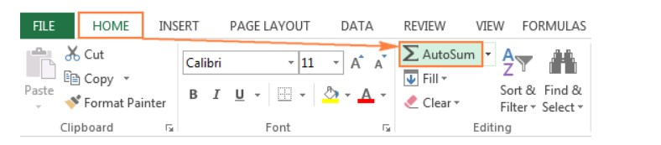

Formulas tab > Function Library group > AutoSum:

Click the AutoSum button on either the Home or Formulas tab.

A Sum formula appears in the selected cell, and a range of cells you're adding gets highlighted (B2:B6 in this example):

In most cases, Excel selects the correct range to total. In a rare case when a wrong range is selected, you can correct it manually by typing the desired range in the formula or by dragging the cursor through the cells you want to sum.

Press the Enter key to complete the formula. and we get autosome formula.

AutoSum is a Microsoft Excel and other spreadsheet program function that adds together a range of cells and displays the total in the cell below the selected range. For example, if you wanted to add the values of cells between A1 and A5, highlight cells A1 through A5 and click the AutoSum button

**2. What is the shortcut key to perform AutoSum?**

**Ans**- To perform an auto sum in Excel for the values you have in the cells above the active cell or the values in the cells from the left, you can use the shortcut key Alt + =. When you press this shortcut key, it inserts the sum function in the active cell by referring to the range that’s above or on the left.

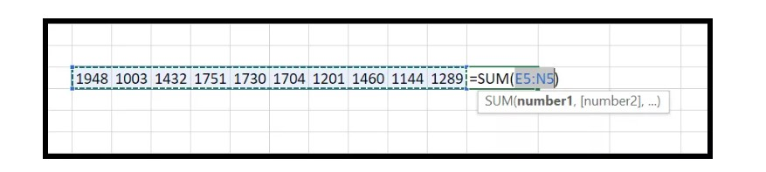

Now as I said, you can also insert an auto-sum for the values that we have on the left side.

**3. How do you get rid of Formula that omits adjacent cells?**

**Ans**- When a formula is entered in Excel and the "Formula Omits Adjacent Cells" error occurs, is there a way to "ignore error" for the entirety of a column? I've ignored the error on the individual cell but when I populate the entire column to reflect the equation of the cell the error re occurs.

To turn off the notification "Formula Omits Adjacent Cells" you're getting, kindly follow the steps below:

1-Open Excel and then click on File.

2-Go to Options and then select Formulas.

3-Look for Error checking rules and uncheck Formulas which omit cells in a region.

4-Click OK.

The error formula omits adjacent cells means that Excel cannot calculate the formula because it is missing something.

Excel tries to calculate a formula but only considers the values from one cell, ignoring other cells with values needed for the calculation.

If this happens, it means that you have left out a cell on one side of your formula and need to clean up your sheet.

First, check to make sure that your formula includes all the necessary parts.

If you are working with a small data set, try to identify any empty cells and delete them.

1. Uncheck formulas that omit cells

2.Launch your Excel sheet and then click on File.

Navigate to Options and then select Formulas.

3-Look for Error checking rules and uncheck Formulas which omit cells in a region.

4-Click OK.

**4. How do you select non-adjacent cells in Excel 2016?**

**Ans**-It’s easy to select a block of cells with your keyboard or mouse. Read on to learn how to select nonadjacent cells in Excel and Google Sheets. Press the shift key and move the cursor to the cells. It’s even easier with a computer mouse. Click on the cell and drag the cursor over the ones you want to work on.

With either of these methods, you can select rows and blocks of cells, but how do you select nonadjacent cells on a Google Sheet and Excel

When we want to select cells on a google sheet, you have four options. Anyone wanting to know how to select nonadjacent cells in Excel can follow the same simple steps.

Selecting Non-Adjacent Cells with a Mouse

Along with your mouse, you also need the computer keyboard to select one or more rows and columns.

Click on the cell.

Press the Control key on the keyboard. Keep holding it down while you are selecting cells.

Hold the left-click button on the mouse and drag it to the cells you want to select.

Selecting NonAdjacent Cells with a Keyboard

Using your keyboard and mouse to select cells is the easiest method. You can also lose the mouse and only use your keyboard. If you want to know how to select non-adjacent cells in the online excel app, this is the best method. You may not be using a mouse if you are working on a mobile device.

Using only a keyboard takes a few more steps than with a mouse. Don’t worry. It’s still easy to select nonadjacent cells.

1.Use the pad or arrow keys on your keyboard to move the cursor to the cell. Now it is the active cell.

Hold down the F8 key; it’s at the top of your keyboard. Check your status bar it should read Extend Selection.

2.Use the arrow keys on the keyboard to select single cells, rows, and columns. Pressing the F8 key activated the Extend Selection mode, so you automatically have a selection of the adjacent cells.

3.When you are done using the Extend Selection mode, simultaneously hold the F8 and shift keys down. Now, you are back in Add or Remove Selection mode. You can add cells, delete them, and make other edits.

4.When you want to select another cell, repeat the four steps. Don’t forget to turn off Extend Selection. Leaving it on may prevent you from making any edits or adding new cells to the sheet.

Using the above four steps, you can select two non-adjacent cells at a time.

Selecting Non-Adjacent Cells with the Name Box: -

When you want to select one or more cells and don’t have a mouse, you can use the Name Box. It only works in Excel, but it’s a quick and easy method when you are selecting nonadjacent cells.

The Name Box is to the left of the formula bar. It’s visible, so it’s easy to find.

A handy tip, using the Name Box is the fastest method when you know the name of the cell you want to select. If you don’t know the name, it’s easier to use the mouse and keyboard.

1.Click the Name Box tab. It opens the dialogue box and moves the cursor inside. Now, you can type in the name of the cell.

You can enter the names of one or more cells. If you are searching for multiple cells, separate the names with a comma.

2.Press the Enter key.

3.Pressing Enter automatically brings up and selects the specified cells. The last cell entered the Name Box is the active one. It’s something you want to remember.

Sometimes, you don’t know the name of the cells you want. You can use the Name Box to search for ranges of non-adjacent cells.

When you are naming your cells, keep a list or the ranges simple. Naming a range of cells Data 1, Data 2, etc., makes it easier to select them using the Name Box.

Using the Find & Replace Function: -

When you are looking for cells with a specific value, this is the fastest method. It only takes a few steps, and you can select all the cells with a certain name or number.

It’s a handy tool to use and makes it easy to pull up specific information when needed.

The Find & Replace function works with Windows and Mac, though you may use different commands depending on the operating system.

1.Select the data range.

2.Press down on the Control and F keys simultaneously. Mac users will hold three keys, Command, +, F.

A dialogue box will open with two options, Find and Find What. Type the cell’s name or value in the Find What field.

3.Click the Find All tab. It’s at the bottom of the dialogue box. The function will start searching for all cells that match the entered field.

4.Press the Control and A keys. The selected cells will appear underneath the dialogue box.

5.Close the Find & Replace box. You should have the non-adjacent cells you need.

we can select cell contents in Excel using the Find & Replace function. It also allows you to edit any data contained in the cells.

**5. What happens if you choose a column, hold down the Alt key and press the letters**

**ocw in quick succession?**

**Ans**-The column width dialogue box opens allowing you to set the exact width of the column.

You can insert a value in the column width dialogue box for how wide you would like a column to be. This is especially useful if you have several non-adjacent columns that you need to be the same width.

**6. If you right-click on a row reference number and click on Insert, where will the row**

**be added?**

**Ans**-If a cell is selected prior to pressing the preceding shortcuts (entered in step 1), the “insert” dialog box is displayed. However, if a row is selected, these shortcuts insert a new row directly.

Step 2: The “insert” dialog box displays the following options:

Shift cells right: This shifts the content of the selected cell (selected in step 1) to the cell on the immediate right.

Shift cells down: This shifts the content of the selected cell (selected in step 1) to the immediately following cell.

Entire row: This inserts a new row preceding the row of the selected cell (selected in step 1).

Entire column: This inserts a new column to the immediate left of the selected cell (selected in step 1).

Since we want to insert excel row 6, we select the option “entire row.” A new, blank row 6 is inserted, as shown in the following image. With this insertion, the entries of the initial row 6 shift to row 7.

